

**A decision support system for modeling and mapping the virulence of entomopathogenic fungi in integrated pest management**

**Ritter A. Guimapi**

**Samira A. Mohamed**

**Lisa Biber-Freudenberger**

**Sunday Ekesi**

**Christian Borgemeister**

**Henri E. Z. Tonnang**

# Acknowledgments

The first author of this study is a PhD student working in the fellowship project (VW-89362) of Henri E.Z. Tonnang funded. by the Volkswagen Foundation under the funding initiative Knowledge for Tomorrow - Cooperative Research Projects in Sub-Saharan on Resources, their Dynamics, and Sustainability – Capacity Development in Comparative and Integrated Approaches. The authors thank the Federal Ministry for Economic Cooperation and Development (BMZ), Germany that provided the financial support through Tuta IPM project, the German Academic Exchange Service (DAAD) and the STRIVE project funded by the German Federal Ministry of Education and Research.

# Installation

Before you start installing EPFA_1.0 software, make sure you have about 450MB of free space on you disk and have also downloaded all the necessaries tools. This include, the **Setup (setup-EPFA.exe) and the requirements (R-3.2.3-win and R packages).**

To begin with the installation, double-click on the file **“setup-EPFA.exe”.** On the windows that opens, choose the language for the installation process and click on **“OK”.**



**Figure 1**: Language selection

Accept the licence agreement, and click on **“next”**



**Figure 2**: License Agreement

Specify the destination location.



**Figure 3**: Destination Location

Continue to click on “next” until the window asking to add a shortcut on the desktop. Check for the creation and continue to click next till the end of installation. The end of the installation launch the software which open the “Model Builder perspective” as default display.



**Figure 4**: Welcome window

# Install the requirement

The next task consists to install R-software and R-package.

Click on **“Install tools”** in the toolbar.



**Figure 5 :** Install the requirement selection

The window that opens allow you to complete the installation. Select the folder containing all the requirement; install first R and therefore Rserve and R libraries.



**Figure 5.1:** Install requirement window.

After completed the installation, It is time to create a project a make some simulations.

# EPFA keys functionalities and user interface

## Input data

The virulence data are obtained from laboratory experiments over a wide range of constant temperature where both insect and the entomopathogen can develop. Insects are initially let in contact with the EPF and put in a Petri dish or a box; then the number of dead insects is recorded daily till the end of the experiment. At each temperature, the experiment is replicated and mortality is then recorded daily till the defined duration of the experiment. The figure below present the two time-dose mortality data recorded from laboratory experiments can be structured to serve as input in EPFA software.

InputData1.tif

**Figure 6:** Two options for the structure of the EPF laboratory-virulence input data file represented in part A and B with data on temperature, the number of replications of each experiment (replicate), the day of observation, the number of insects alive (survivor) and the mortality. In part(A)mortality is recorded as the number of daily dead individuals for every replicate and in part (B) mortality is recorded only at the end of the experiment for each replicate as a percentage of dead individuals.

## Project creation

To create a new project, open R software and load “Rserve” package (Figure 7). Then go to EPFA software click on **File ->New -> Other->EPFA Project**. The window presented below is displayed for user to input information such as: project name and name of the EPF, the name of author of the project, and a brief description of the project. Once the user clicked on the “Finish” bottom, the project is created and stored.

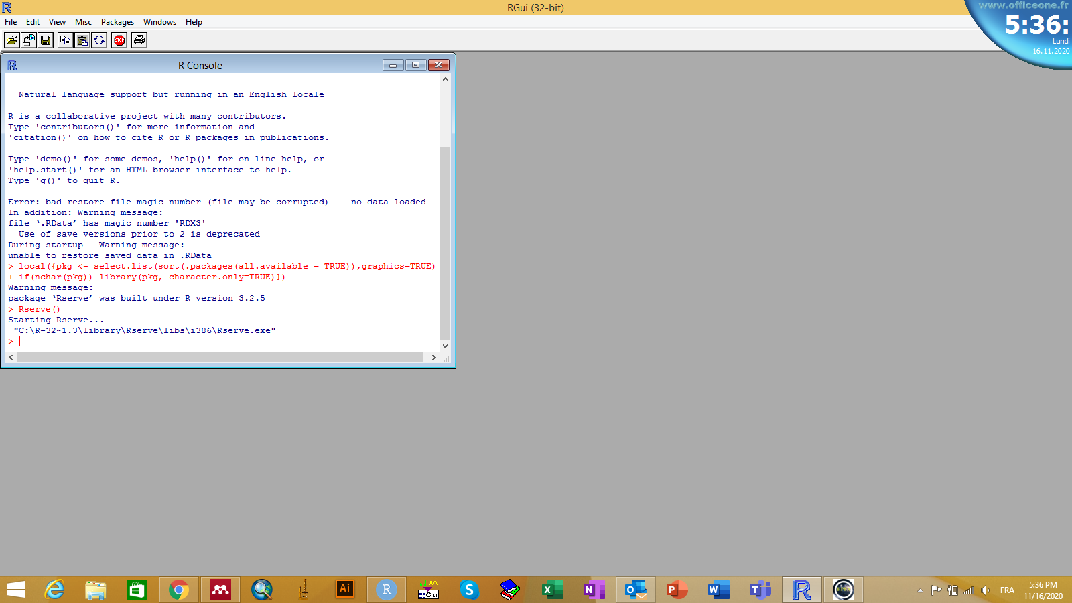

**Figure 7**. Loading Rserve package in R

project creation 4.01.tif

**Figure 8:** Project creation frame to specify the project name, the fungi species of concern, the author, date and observation name to provide general description about the project in creation.

## Development of temperature dependent mortality model

After the creation of the project, the default display in the environment of the tool is the model designer perspective. It guides EPFA software users on the development of the virulence model of the fungal-based bio pesticide.

**welcomming windows.tif**

**Figure 9:** "Model Designer" perspective. EPFA software welcome frame. Once the user created a project, it appears automatically in the "Project Explorer view" at the left of the frame.

The process starts by loading the mortality data file into the project (Figure 10). Figure 11 presents and overview of the display of the window after loading the mortality data. The left side of the table presents the level of the pest mortality caused by the fungal as per defined temperature values; whereas the right side displays the trend of data. EPFA software offers users the possibility to include additional temperature values different from those considered in laboratory experiments.

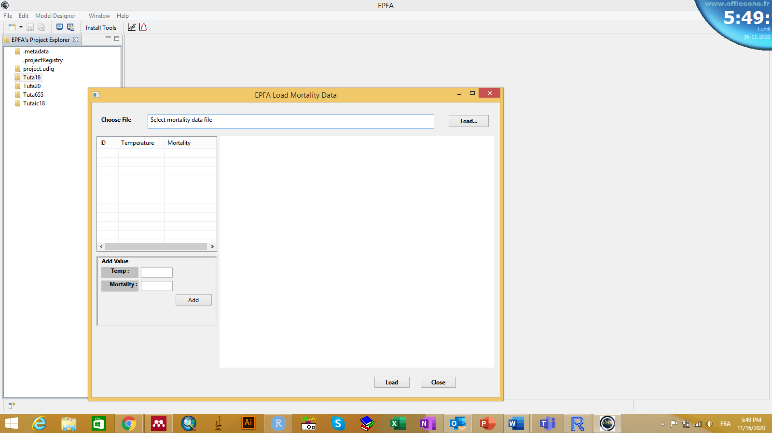

**Figure 10.** Click on the load data icon

**loadPlot4.0.tif**

**Figure 11: UI** for import, plotting and modifying time-dose mortality data.

Once the data are loaded the next step consist of designing the virulence model (Figure 12). Figure 13 below shows the window allowing users to select functions and run the modeling process. The “Multiples selection” bottom enables users to simultaneously estimate parameters of many models while “Single selection” bottom enables users to choose only a model and then estimates its parameters.

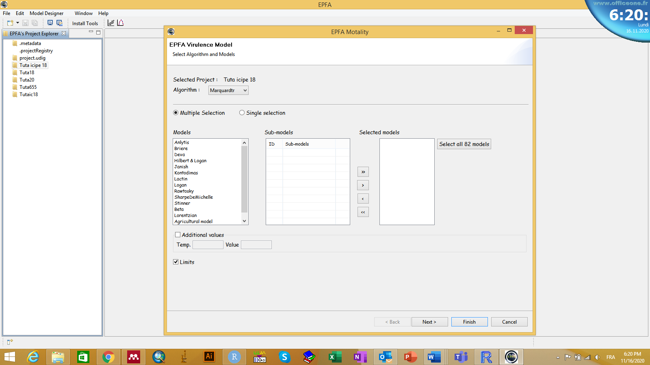

**Figure 12.** Click on the virulence icon

**modeling frames 112.tif**

**Figure 13:** Wizard for temperature-dependent virulence model designing process. This frame allows the user the select models to be fitted with time-dose-mortality data.

Below is the results obtained from “Multiples selection“. For each model, the curve and parameters are displayed. By combining the graphical display with the values of the goodness of fit, the selection of the best model is carried out. The “Accept” bottom is used to confirm the selection and to save and transfer the chosen model into the mapping environment.

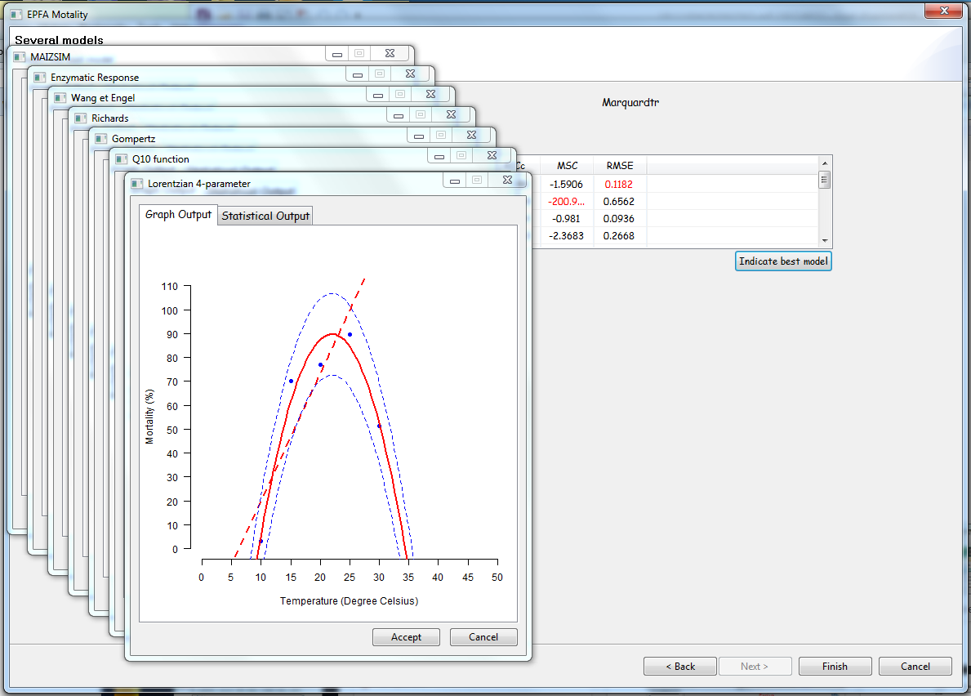

**Figure 14:** User interface for the selection of a model for further analyses.

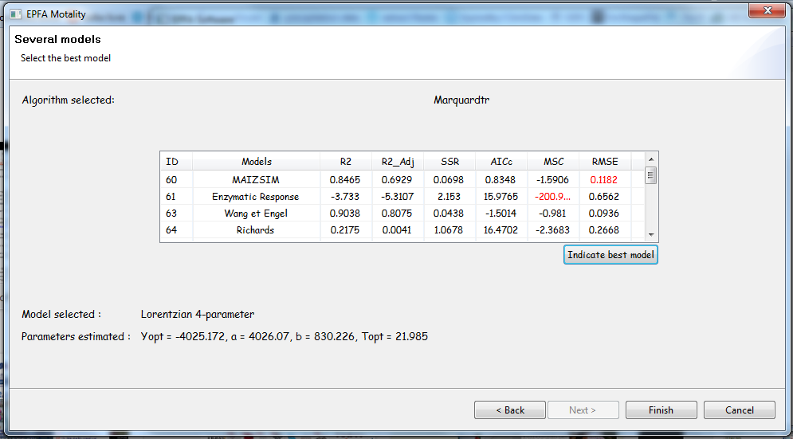

**Figure 12:** Evaluation criteria for the goodness of fit of each applied model. Cells in red suggest the best performing model for each evaluation criteria.

## Mapping the variability in the virulence efficacy of the selected isolate

The first step in the mapping perspective consists of linking the mortality model with the climatic database to generate the map (ASCII file). A click on the icon EPFA software toolbox in the mapping environment, leads to the appearance of the window presented in Figure 16. This window has the following features: path to the climate database, the extent (minimum and maximum latitude and longitude) of the area of interest, the range of temperature values to consider and the path for the output file.

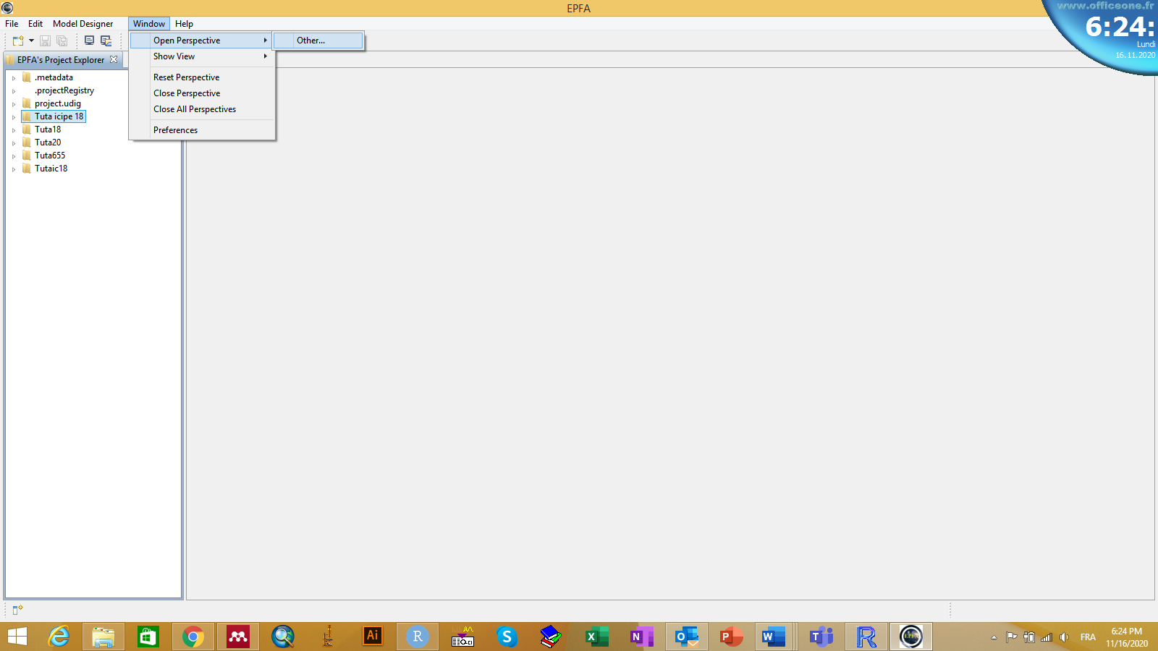

**Figure 13**. Click on window option

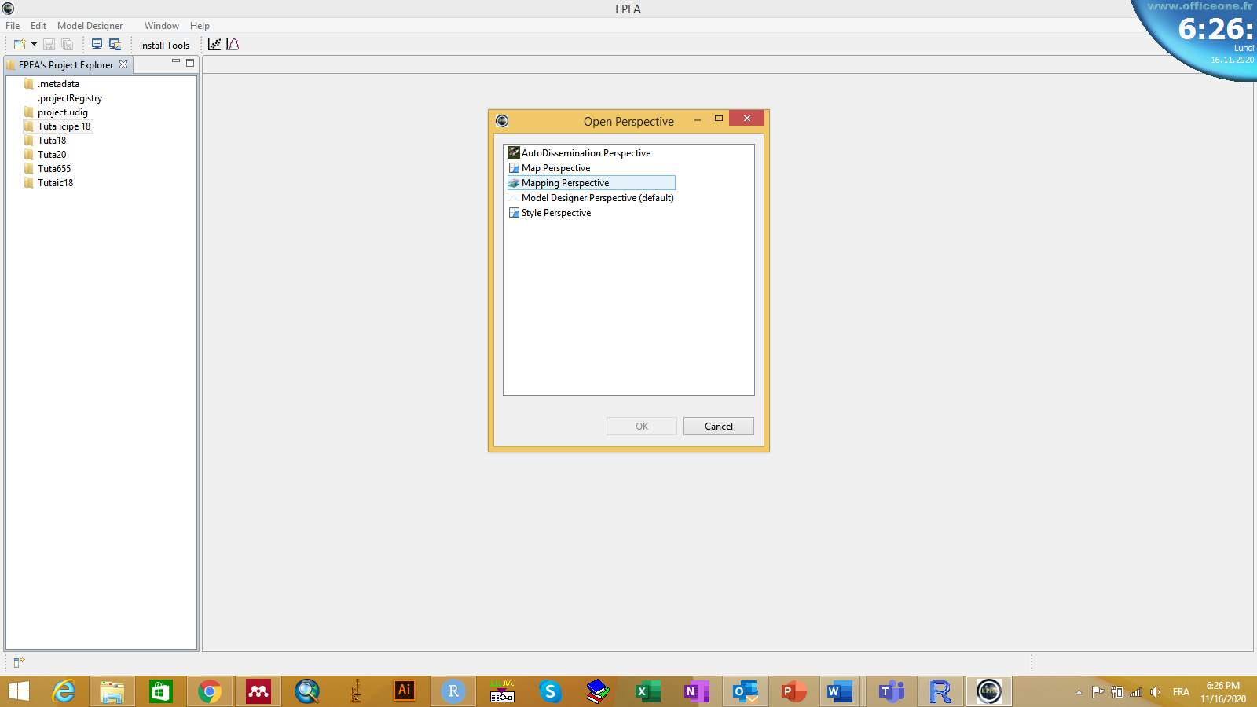

**Figure 14**. Click on mapping perspective

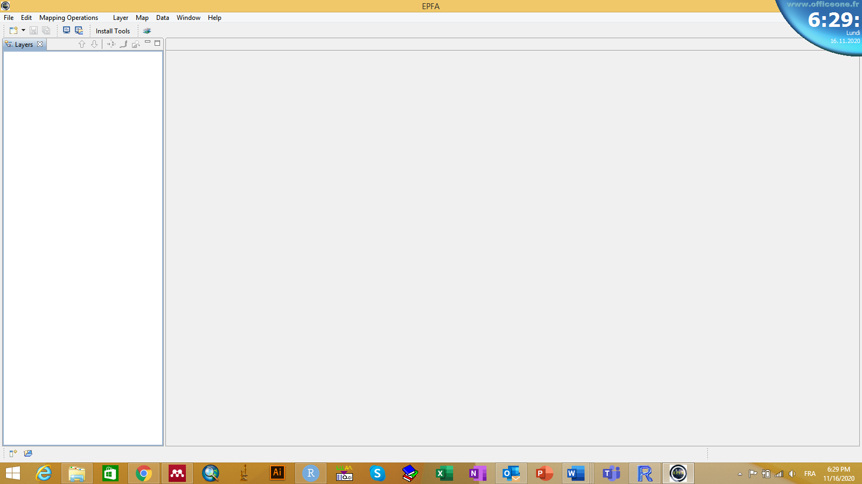

**Figure 15**. Click on generate the map icon

Input Mapping 4.01.tif

# Figure 16: User interface to set parameters for the import of climate data and the application of the model to these data.

After the map is produced, the final step consists of using all the functionality provided in EPFA for editing, adjusting and printing the map as shown in Figures 12-13

Cameroon Mapping result.tif

# Figure 17: Cameroon map of potential efficacy of ICIPE 62 isolate when used against *Mustard aphid* modelled with the EPFA software. The level of efficacy varies between 0 and 1. Locations with zero percent (0%) probability of efficacy are displayed in white values between 0 and 0.5 in blue, values between 0.5 and 0.75 in green and values between 0.75 and 1. In red indicating the highest efficacy levels.

**kenya Mapping result.tif**

# Figure 18: Kenyan map of potential efficacy of ICIPE 62 isolate when used against *Mustard aphid* modelled with the EPFA software. The level of efficacy variesbetween0 and1. Locations with zero percent (0%) probability of efficacy are displayed in whitevalues between 0 and0.5 in blue, values between 0.5 and0.75 in green and values between 0.75 and1 In red indicating the highest efficacy levels.